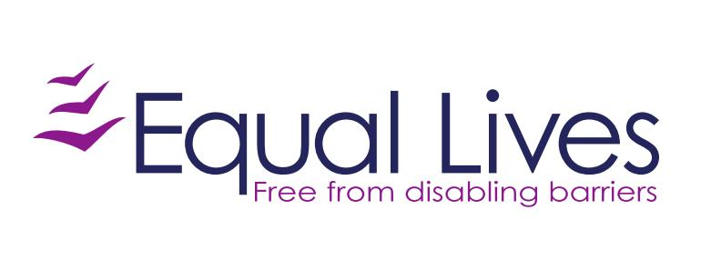

Job Description | Female Advocate
Reporting to: | Advocacy manager

Purpose of the role:

To provide comprehensive advocacy to people facing disabling barriers, with a non-judgemental approach to ensure that individuals are able to make informed decisions about their lives.
Work to empower people to make their own, informed decisions and support them to have their voice heard.
To offer issue-based advocacy to disabled people in the community on areas such as social care, mental health, housing and child protection.

Community Advocate

Principal tasks:

- Providing information, advice and advocacy on a range of issues affecting people who face disabling barriers, currently including:
  - Mental health care
  - Support to access treatment and support services
  - Personal budgets and direct payments
  - Discrimination and employment issues
  - Child protection proceedings
- Being an independent voice for clients.
- Working alongside clients to challenge institutions, organisations and bad practice where needed.
- Visiting clients either at home or in the community and working within Equal Lives’ lone working policies and procedures.
- Communicating with clients in the method that feels most comfortable and accessible for them. This could be via phone calls, emails, letters, video calls, face to face meetings or a combination of all of these.
- Building relationships in order to understand and effectively advocate for people who may not use words to communicate or may find it difficult to express themselves.
- Effectively managing a case list and maintaining comprehensive and up to date case management records using appropriate software and ensuring follow up requirements are carried out in a timely fashion
- Contributing to the provision of induction and training of other staff including volunteers within the service.
- Developing strong working relationships with relevant organisations and institutions to ensure that the needs of clients are met.
- Working as part of the advocacy team and developing a supportive team culture.
- Keeping up to date with relevant legislation, policies and practice relevant to the role.
- Support other teams within Equal Lives by offering advice and information on specialist areas of knowledge, where needed.

General Tasks:

- Working within Equal Lives policies and procedures at all times

- Working in a way which is boundaried. This includes not working beyond set hours except where required on occasion for a specific reason, being consistent and fair with clients and not overstepping the remit of the role.

- Working closely with colleagues to ensure that Equal Lives services are of the highest possible standards

- Working in a way which is empathic and non-judgemental.

- Empowering service users and undertaking all duties guided by independent living philosophy and social model of disability

- Taking part in supervision, case management, team and other meetings as required

- Participating in open days, conferences and other events as required

- Providing cover for colleagues and undertaking other appropriate duties as required

Person Specification: | Specialist Adviser Advocate
Key characteristics: | 3 – High importance  2 – Medium importance  1 – Low importance
A detailed understanding of the barriers faced by disabled people, the Equality Act 2010 and Social Model of Disability | 3
Commitment to equality of opportunity and empowerment of disabled people | 3
Proven ability to advocate and undertake representation including an understanding of the principles of self and peer advocacy | 3
Substantial experience working in an advice/advocacy role including client representation | 3
Specialised knowledge and experience in at least two of the following areas:  - Mental health care  - Social care  - Personal budgets and direct payments  - Disability discrimination and employment issues  - Child protection proceedings | 3
Ability to organise and manage conflicting priorities within own workload and the team | 3
An advocacy qualification at level 3 or equivalent experience | 3
Excellent inter-personal and relationship building skills | 3
Excellent communication skills and proven experience of adapting your communications to suit a variety of different people. | 3
Awareness of the impacts of working with trauma and experience of managing this, as well as an understanding of the importance of self-care. | 3
Experience of working with people with dementia, learning disabilities and/or high mental health needs. | 2
Experience of supporting people through processes. | 1
Experience of working with IT, including Office, Word and Excel | 2
Personal experience of disability | 1
Identifies as Female  (service users can request advocates based on gender. Due to the make up of the existing team, females are preferred for this position) | 2

